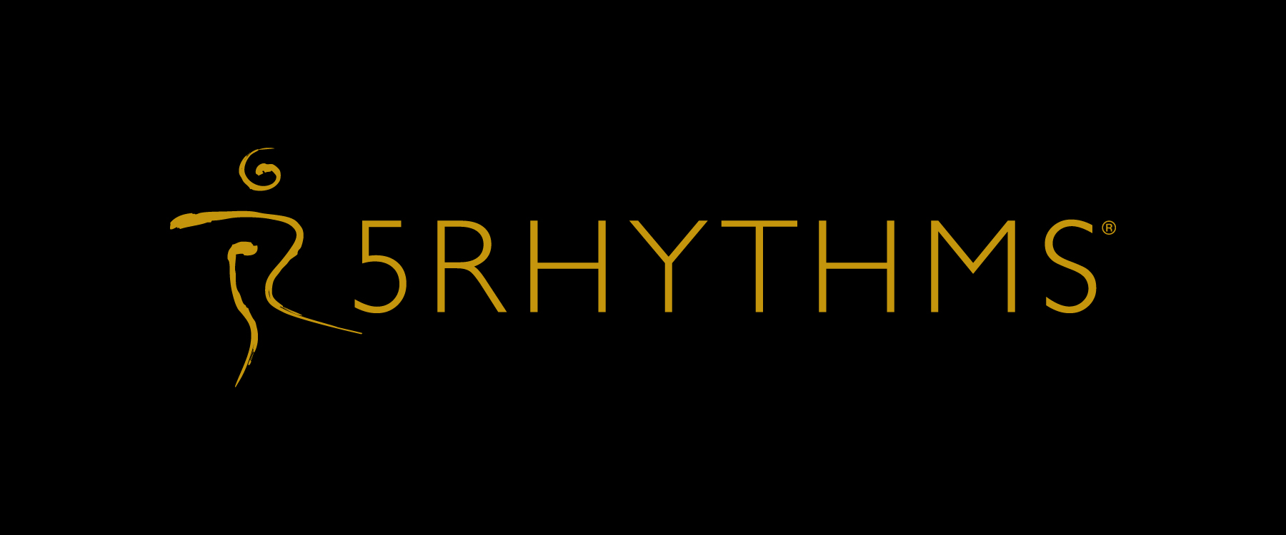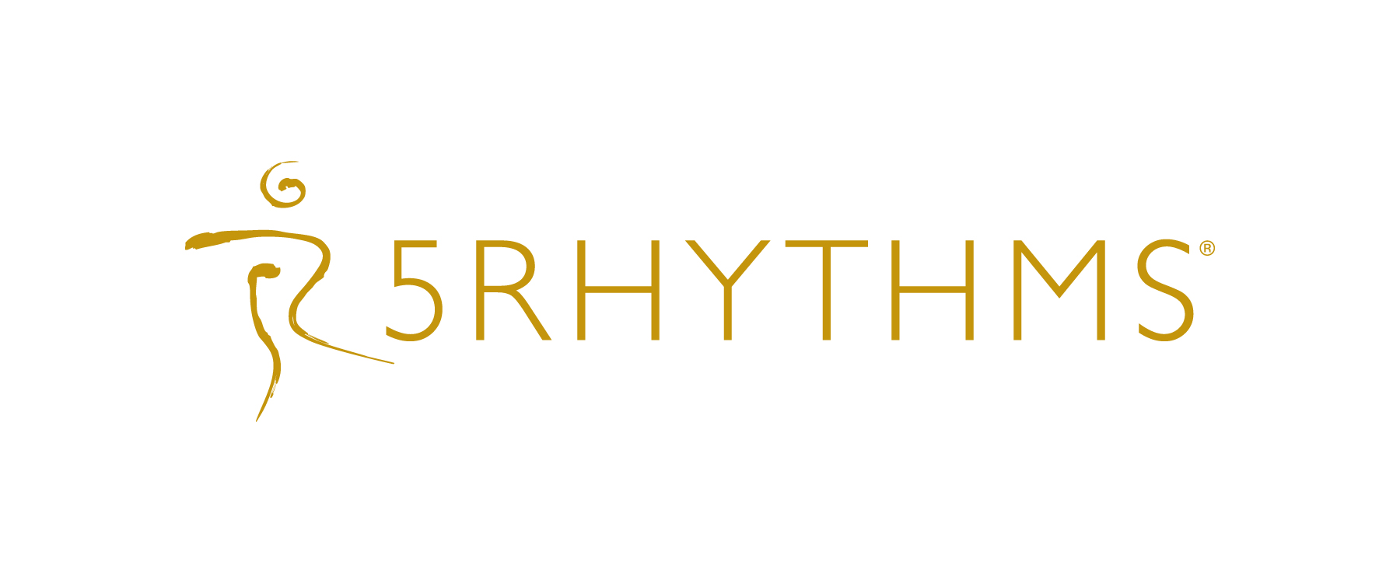

About 5Rhythms®: www.5Rhythms.com
Created by Gabrielle Roth over 50 years ago, amidst modalities within the human potential movement, and now practised by tens of thousands worldwide, 5Rhythms® is a philosophy, perspective, performance art and a dynamic movement practise rooted in the principle that “if you put your body into motion, the psyche will heal itself”. With overlaps in philosophies within Yogic, Shamanic, Sufi and even Jungian psychology fields it straddles both ends: Physical expression as well as Spiritual meditation. Movement is both the medicine and the metaphor, reaching across all languages, cultures and age groups to transform suffering into art, art into awareness, and awareness into action. Wherever the 5Rhythms® are practised, a community is born to dance, to sweat, to change, to support and to provide a safe space for each of us to shatter the ego's hold and awaken the juicy, unpredictable, fascinating, edge-walking, rock star part of ourselves that yearns to be free and alive.

The five rhythms are: Flowing, Staccato, Chaos, Lyrical, and Stillness. They come together to create the Wave®, a movement meditation practice. The Wave® allows us to get in touch with our bodies and innermost feelings, and in the process catalyzes deep healing in the mind, body, heart and soul and brings out their creative potential. Rather than having steps to follow, each rhythm is a different energy field in which you find your own expression and choreography, thereby stretching your imagination as well as your body’s range of articulations. Each rhythm is a teacher and you can expect to meet different and sometimes unknown aspects of yourself as your dance unfolds naturally.

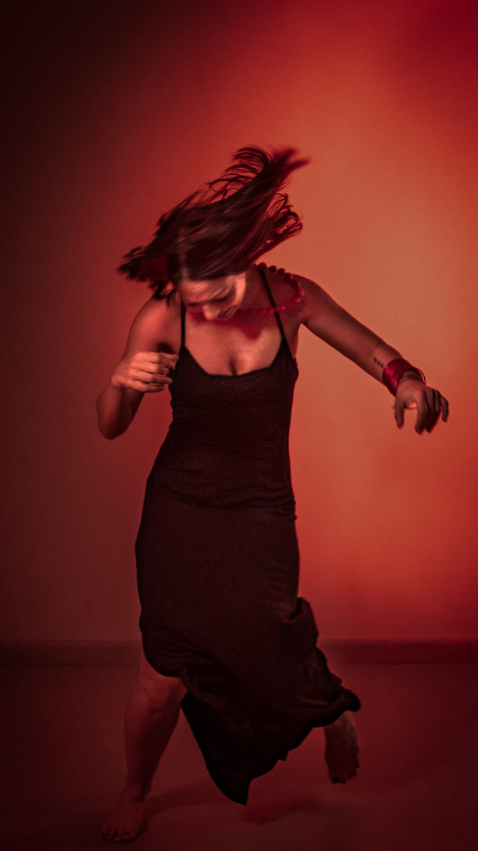

Lina Nahhas, an Arab-Canadian based in Dubai, was one of the first in bringing 5Rhythms® creative dynamic practise to the region in 2010, and her passion for the work has led her to Waves® level teacher certification by 2014, weaving teaching into her life whilst running her social innovation work via The Sameness project. Her daughter, Jood, keeps the flame for her passions alive (and also keeps her on her toes!)
Join in to set your spirit free and land into the present moment feet first….
“The impact that the 5Rhythms® has had in my life, remains magical. One of sentences that gets repeated constantly by those who attend a 5Rhythms® class for the first time is “I feel so free to be me”. And it remains so for me each time, no matter what “me” looks and feels like in the moment of that day! Invoking deeper presence, the 5Rhythms helps my soul inhabit its freedom and lightness in alignment with body, heart and mind with spirit, to savour life more fully and experience ease, by simply tuning in to the natural movement of my body and that of the cosmic dance holding it all. And in my continuing journey with the 5Rhythms®, I wish to offer others an opening to this energy which nourishes true freedom and reclaims our humanity. My favourite quote from my teacher Gabrielle Roth has always been: Do you have the discipline to be a free spirit”

